Miranda Cornwell

Heather Lerner

Museum Curation

September 30, 2014

Collections Survey of the

The Joseph Moore Museum

Richmond, Indiana

Fall 2014

**Introduction**

My professor Heather Lerner, for education purposes regarding our Museum Curation course, requested we complete a collections survey of the Joseph Moore Museum. This survey was focused particularly on JMM’s Herpetology collection.

Collections surveys are typically conducted as a means of “improving the overall care and commitment of collections through increasing staff mindfulness and knowledge of collections care as well as developing long range preservation plans” (Conservation assessment 2014). The collection survey was completed by Miranda Cornwell, Timothy O’Donoghue, Margaret Smith, Elisabeth Sorrows on September 19, 22, and 24th, 2014 and written up by Miranda Cornwell (and made much worse by Heather—for educational purposes!).

**General Museum Overview**

The Joseph Moore Museum was established in 1847 and is located on the campus of Earlham College adjacent to Dennis Hall in Richmond, Indiana. It is open on Mondays, Wednesdays, Fridays, Saturdays, and Sundays (1-5pm) and admission is always free. The museum serves as an educational tool providing various learning opportunities for students, especially those interested in museum techniques and curation, faculty, and to the public. The mission statement of the Museum is as follows:

“The ***Joseph Moore Museum*** *inspires learners of all ages* *to connect with and appreciate nature* *including the ancient world and its peoples,* *using a scientific lens.*

**General Building and Facilities**

Physical facilities

**Temperature and Relative Humidity**

Temperature remains to be a detrimental factor in the sustainability of collection rooms. Both high and low levels, as well as major fluctuations, of temperature contribute to a long and mostly subtle deterioration of museum specimens (AMNH 2014). It was evident that the Joseph Moore Museum Herpetology Collection was kept at a steady and adequate low temperature, aiding in the long-term survival of materials located in the storage room (Figure 1). A thermometer, air conditioning system, metal cabinets, closed windows, basement level, and small room were several of the factors that contributed to the cool temperature in this collection room. Although maintaining a cold storage room is usually beneficial to the preservation of materials contained within storage having too cold of an environment could result in the “deterioration, hazing, and cracking of specimens” (AMNH 2014). In fact, during the survey we found a cracked turtle shell possibly due to the temperature fluctuations (Figure 2). As for fluid collections, very low temperatures may even cause deposits on specimens due to the solidification of fats and lipids (AMNH 2014). Therefore, a recommended temperature of consistent 70 F would suffice, specifically regarding fluid collections. Evidence revealed that, fortunately, consistency in the level of temperature was not a problem. If it were, we probably would have observed several loose lids due to the differing expansions of glass and plastic. This did not appear to be the case for humidity as data showed dramatic fluctuation over just two days (refer to photo number two). Storage was mostly composed of metal, which would benefit from low relative humidity levels. In general, specimens will do best in an environment with stable and moderate humidity levels or kept similar to temperature levels; low as practically and comfortably possible. This usually means keeping a relative humidity level of 50% while avoiding dramatic shifts between 40%-60% as these shifts cause much physical damage on specimens. Fluctuation in humidity levels can also occur as much as 38% if AC systems are frequently turned on and off. For the time being the collection may appear to be in pretty good condition but overtime deterioration may occur, as humidity appears to be unstable.

Temperature and Relative Humidity Recommendations:

* One way to cheaply control relative humidity is by using well-sealed storage cabinets or through the use of buffering materials such as acid free tissue, wooden drawers, silica get etc.
* Informing yourself and museum staff of conditions that your collection is subject to so that solutions can be thought out ahead of time.

1.) 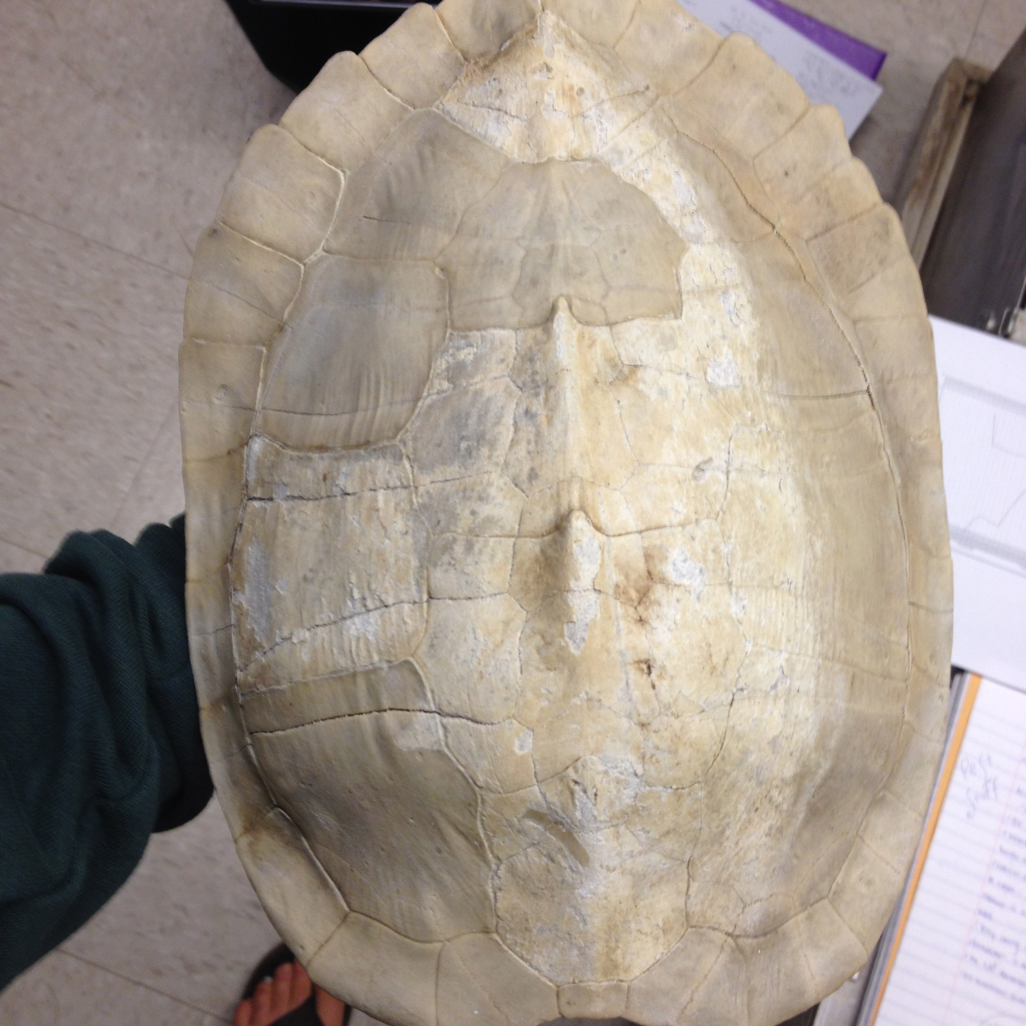 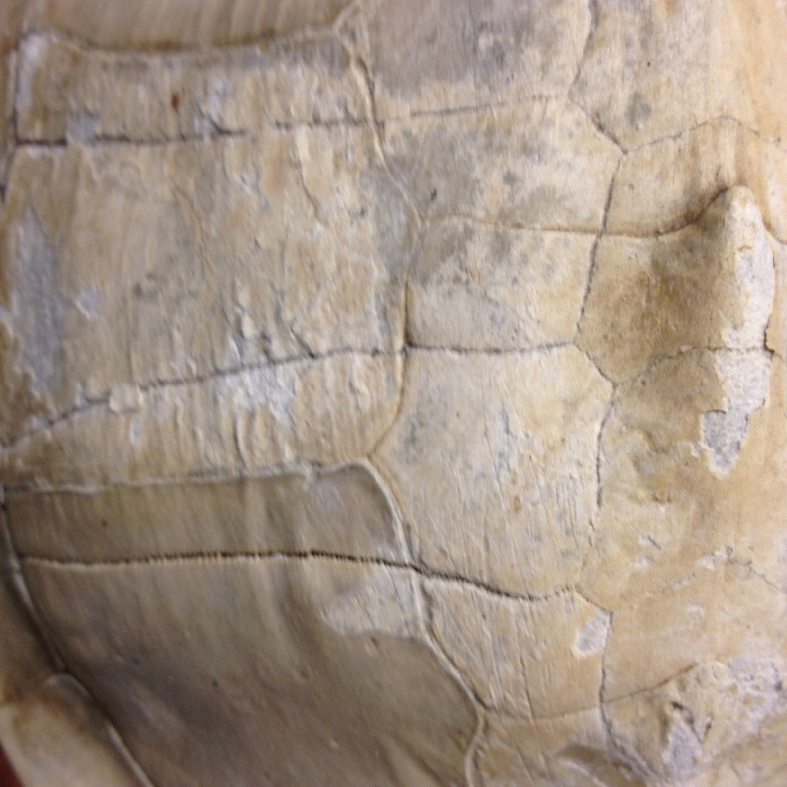

2.) 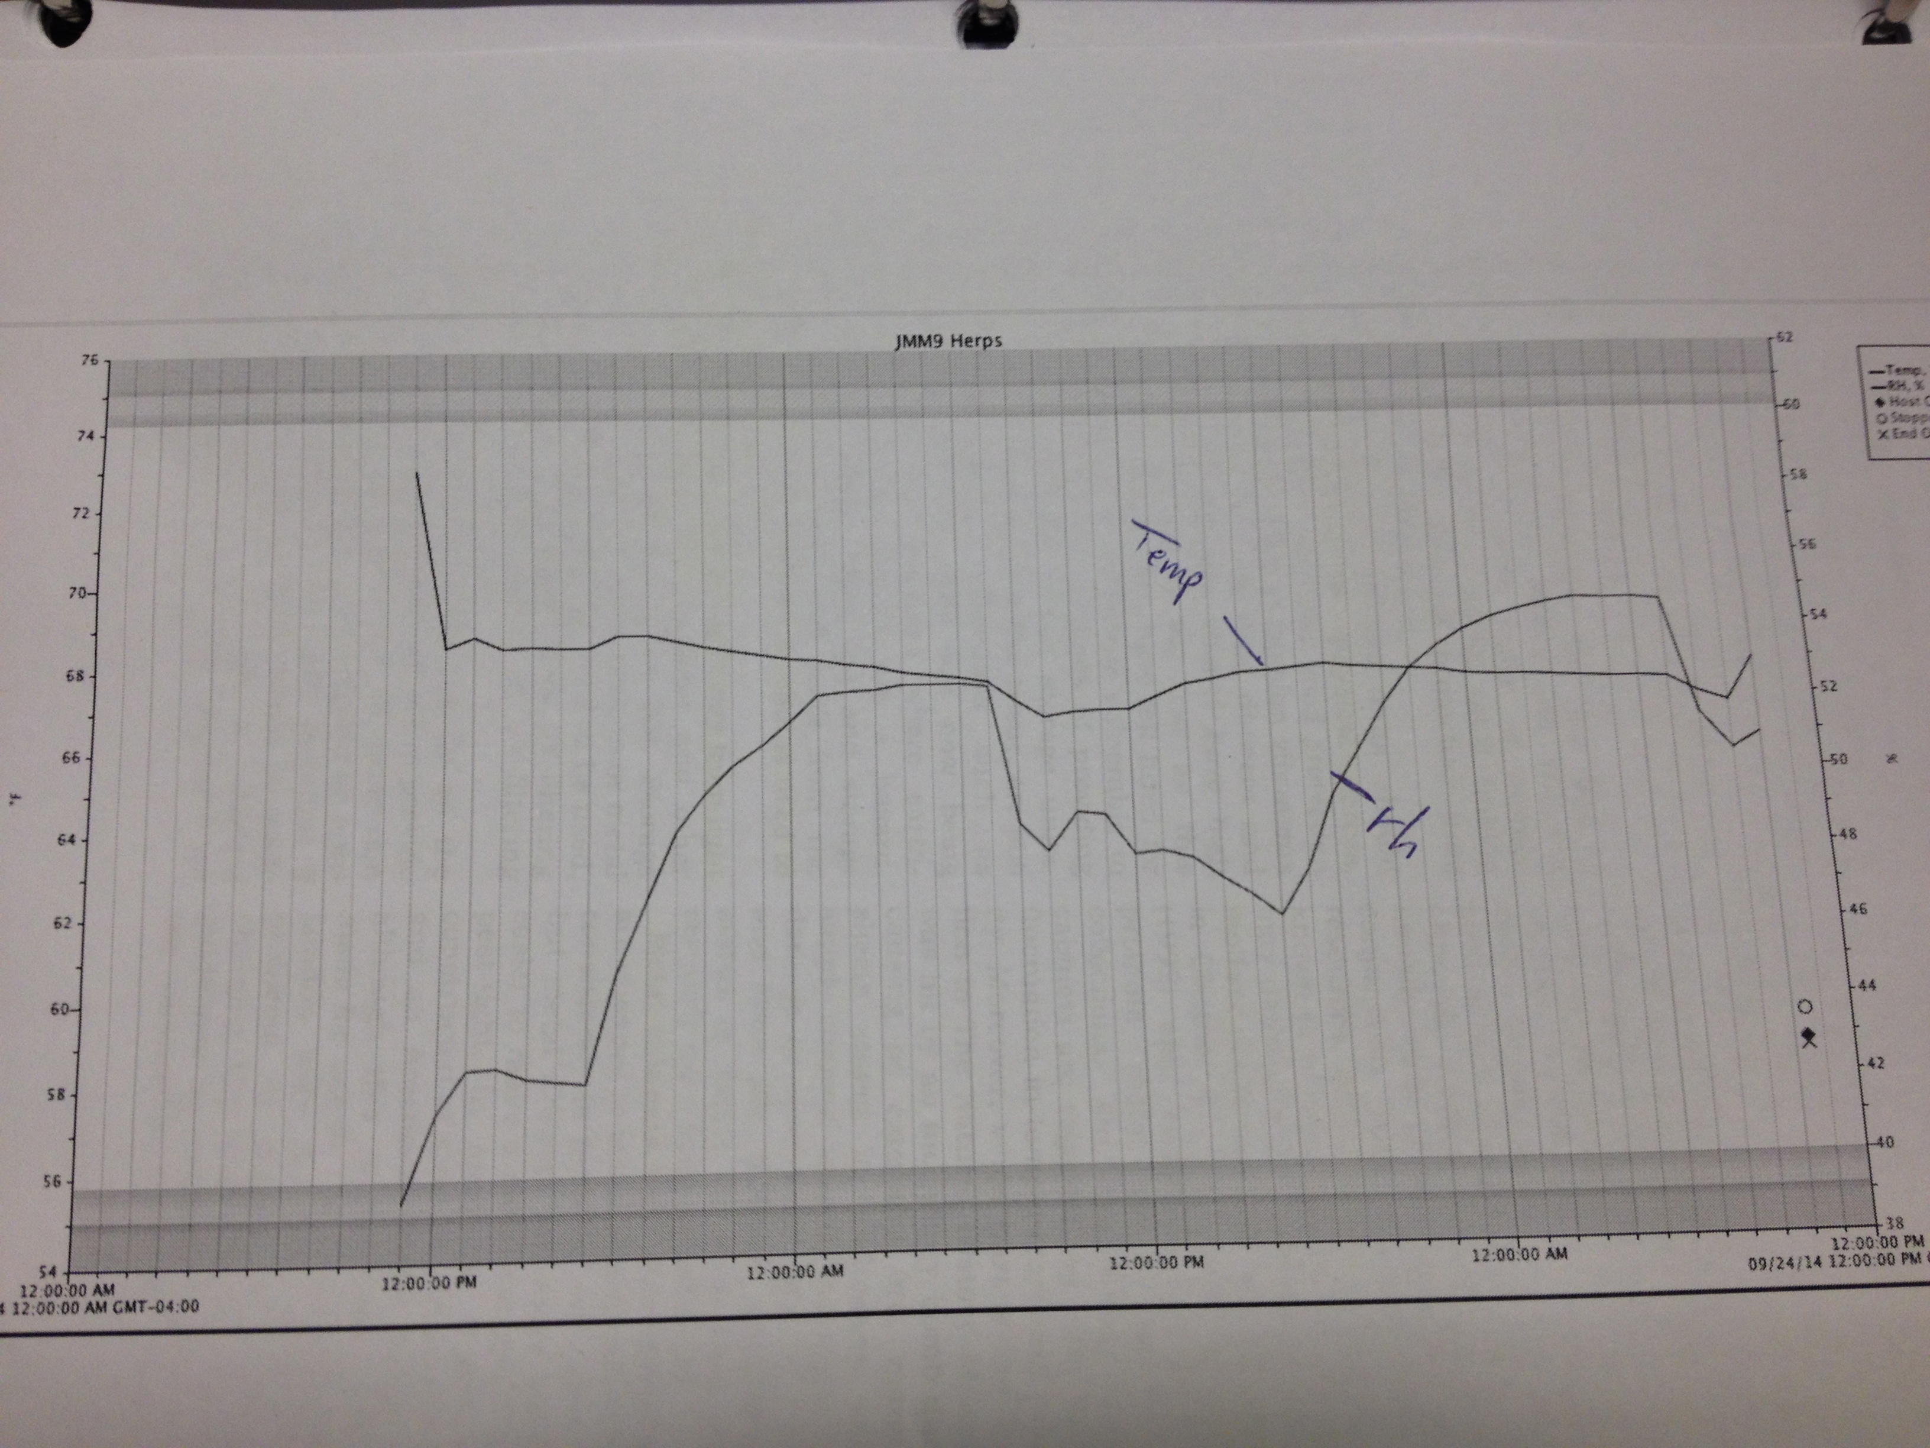

Pest Control

Pest infestations can be easily overlooked but it is crucial to note that they can pose extremely dangerous threats on collections. Although the survey was completed on JMM’s Herpetology room pests are still likely to find a way in. It is incredibly important to minimize and eliminate all sources that attract pests by taking various prevention methods. For instance, during the survey we noticed a box on top of the cabinets that contained specimens from the Bahamas (refer to photo number three below). Similarly, we also found a pair of field boots randomly placed within the collection room (refer to photo number two). These are risky behaviors as various germs, bugs, and pests could have accompanied that box and pair of boots into the collection room. This act also indicates that objects are probably not isolated and examined before entering the collection area. In looking around the site we also saw that the windows did not contain screenings against pests, leading us to discover biological activity such as dead and alive bugs, primarily in the windowsill but also on the shelf near the lamp and boots (refer to photo number four and two). Another potential problem we noted was the presence of books in the collection room. Books are always great and useful but in practicing pest prevention having them stored in the collection room may not be the best idea. Storing the books outside the room may be safer for the books as well as the storage room itself. Due to the evidence provided above it seems safe to say that as of the survey analysis pest eradication techniques are not an issue on the collection.

Pest Control Recommendations:

* A regular and systematic monitoring system is recommended in preventing pest infestations.

1.) 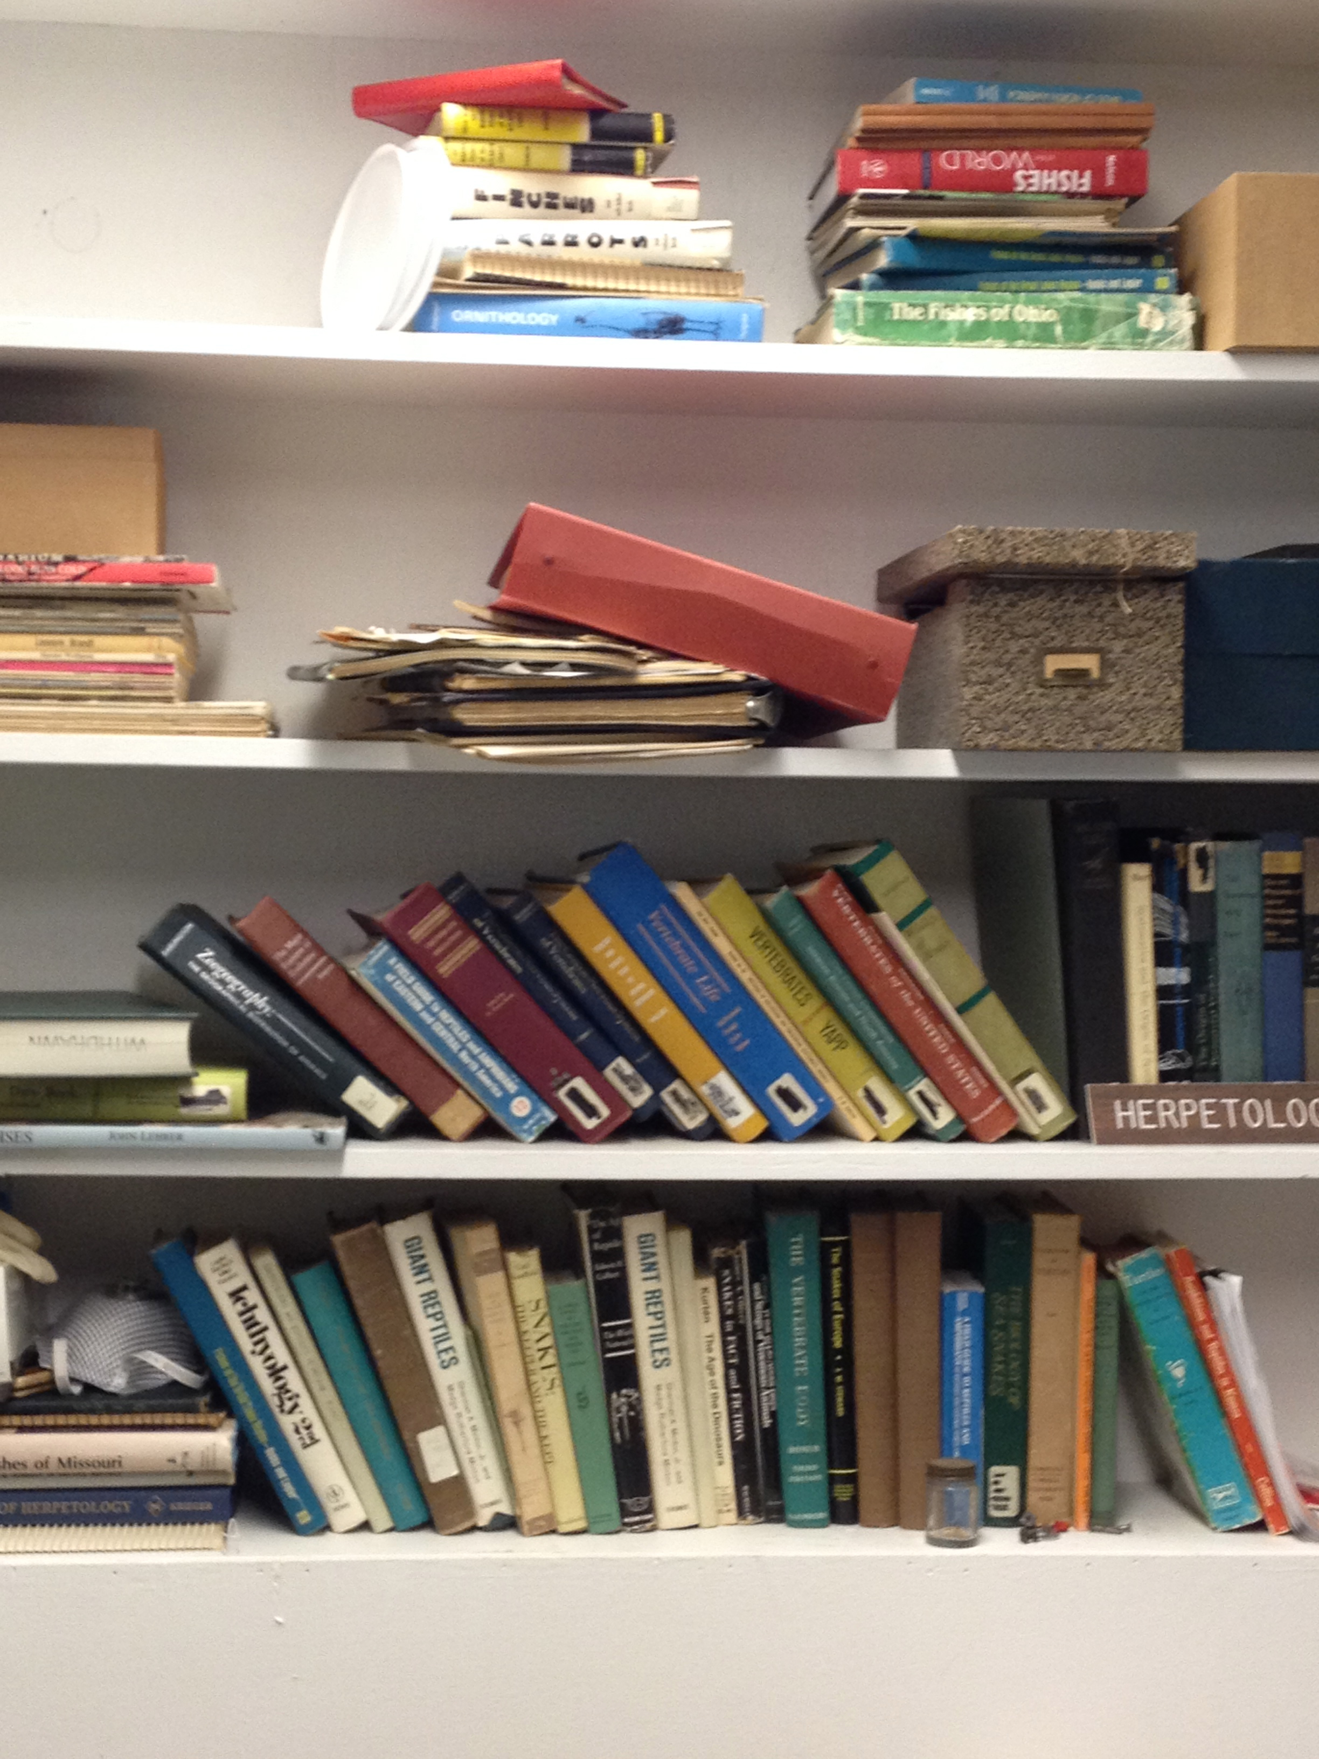 2.) 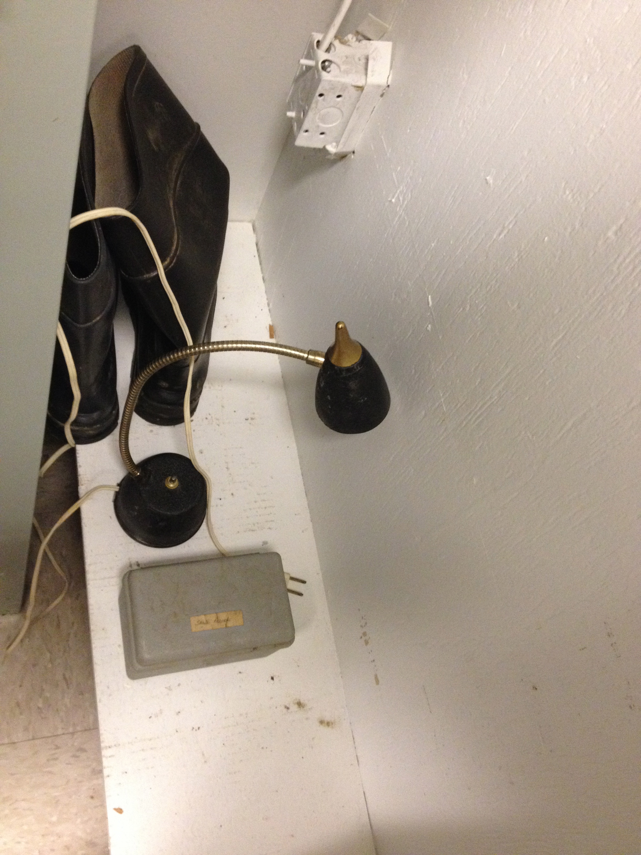

3.) 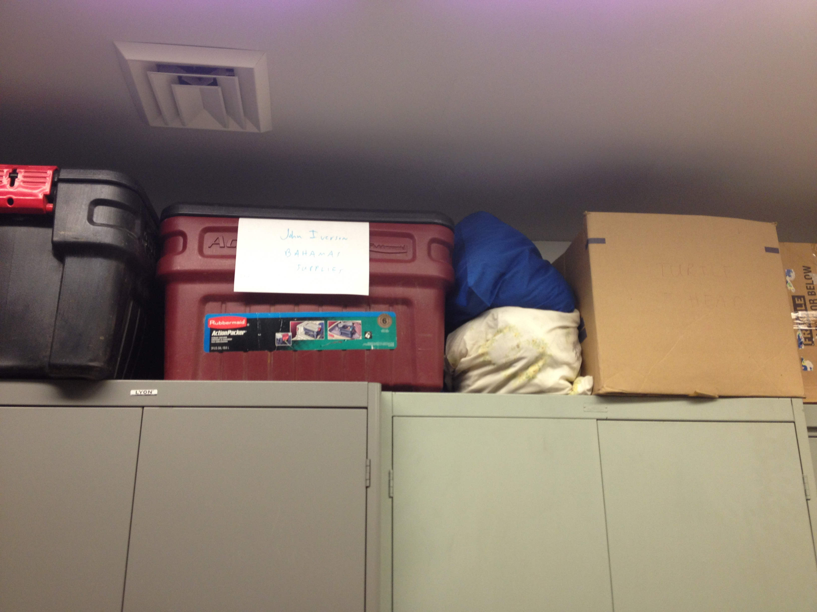 4.) 